REF: LIR/KEG

27 May 2022

Dear Parent/Carer

In anticipation of the new school year in September we would like to share with you some changes to our School Uniform Policy.

As an Academy we have decided to introduce an Academy Skirt. The reason for this change is so we can bring more uniformity to our dress code.

We believe school uniform is very important because it trains students to dress smart and feel pride in their appearance from early life. It brings uniformity and equality among students; it develops a sense of belonging to a particular school; it develops a learning atmosphere amongst students and it teaches discipline.

This will be the ONLY acceptable school skirt for our students to wear at North Durham Academy.

It is available for purchase from The School Outfit - https://theschooloutfit.co.uk/collections/north-durham-academy

The skirt is £14.95 and can be delivered to your home or the Academy for you to collect from Reception.

Alternatively, students can wear black school trousers which can be purchased from a number of retailers. Black school trousers are the only alternative to the Academy skirt.

Another change to our Uniform policy is branded black pumps are no longer allowed at Consett Academy – no buckles, logos, colours except black. Vivienne Westwood pumps are no longer allowed. We also do not accept boots, unless due to adverse weather.

For more information on all changes to our Uniform Policy and for more details about the Academy skirt, please go to our website – https://northdurhamacademy.co.uk/academy-life/uniform/

If you are experiencing financial difficulty during this time please get in touch with your child’s year manager to discuss your options.

I thank you in anticipation for your support and co-operation with this matter.

Kind Regards
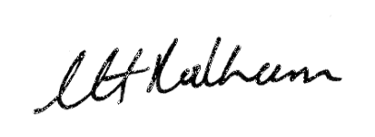

Linda Rodham
CEO of NCDAT and Acting Principal of North Durham Academy

